Name: Mrs. Rupali N Hosmani.

Course: Executive Post Graduate Certification in Cloud Computing

Contact No. 7720003531

**Assignment 3: Jenkins**

**Task To Be performed:**

**A] Assignment 1:**

● Trigger a pipeline using Git when push on Develop branch

● Pipeline should pull git content to a folder**.**

**Steps:**

1.Launch an EC2 ubuntu instance ,connect it & install java & Jenkins .

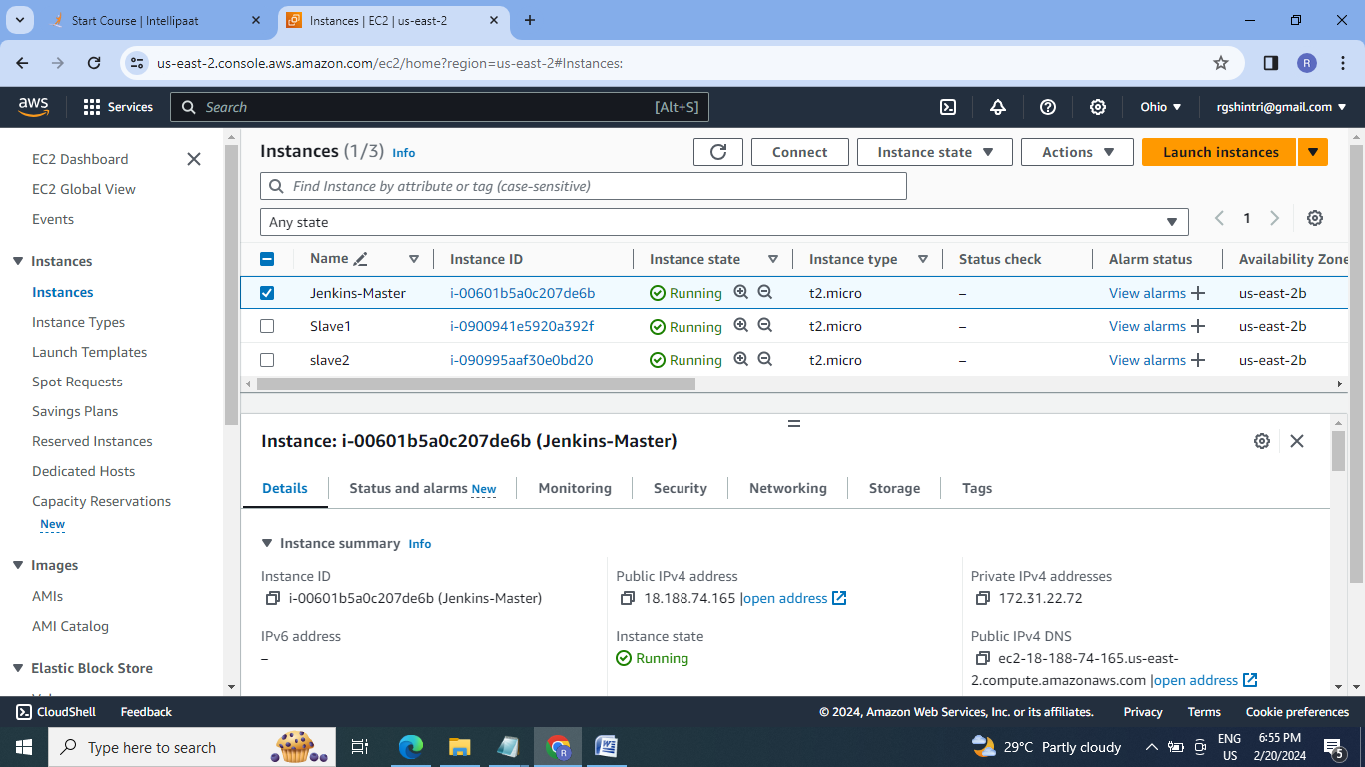

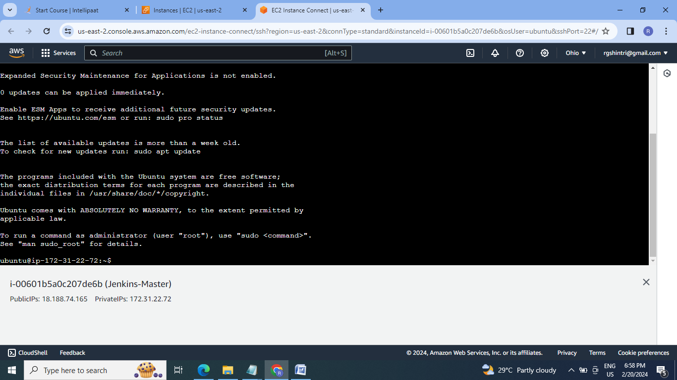

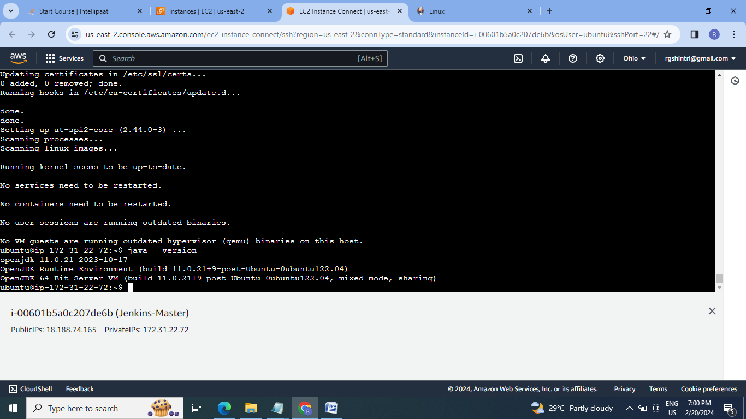

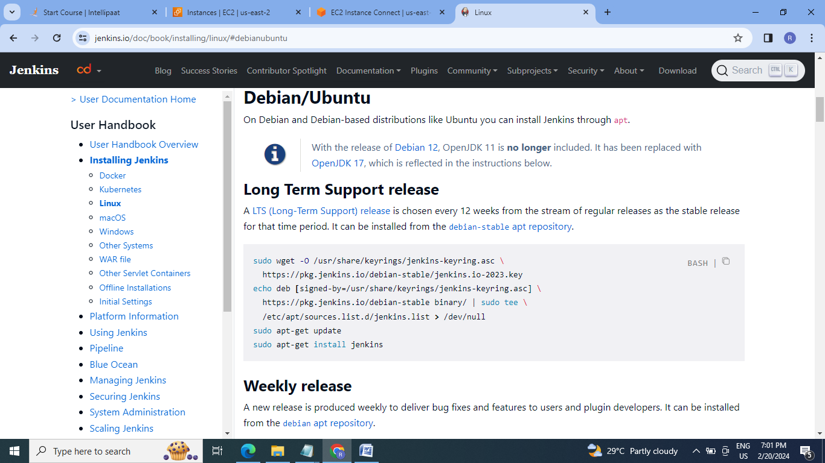

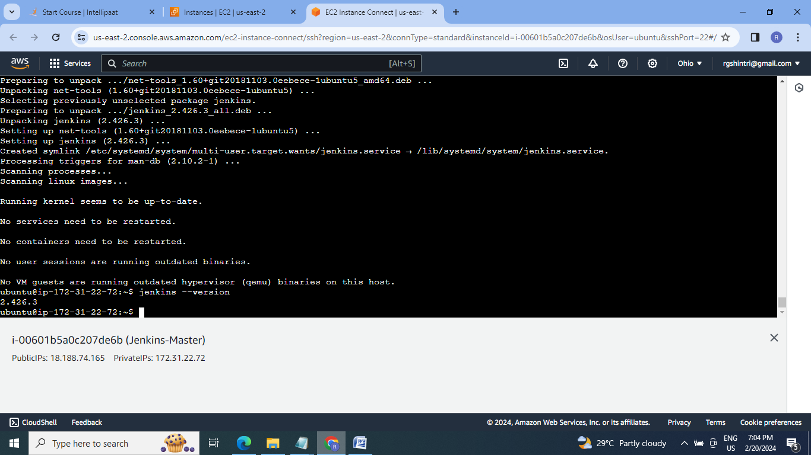

2.Access the Jenkins GUI:

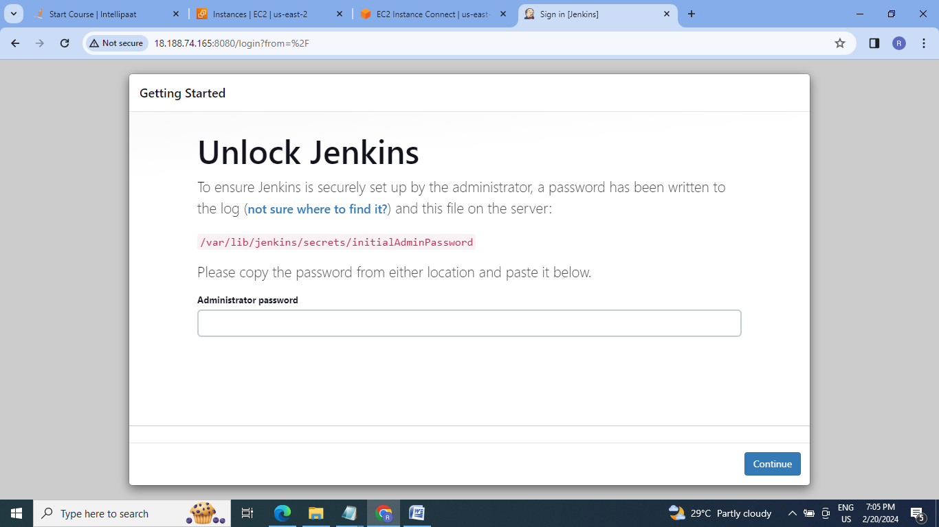

3. Unlock the Jenkins:

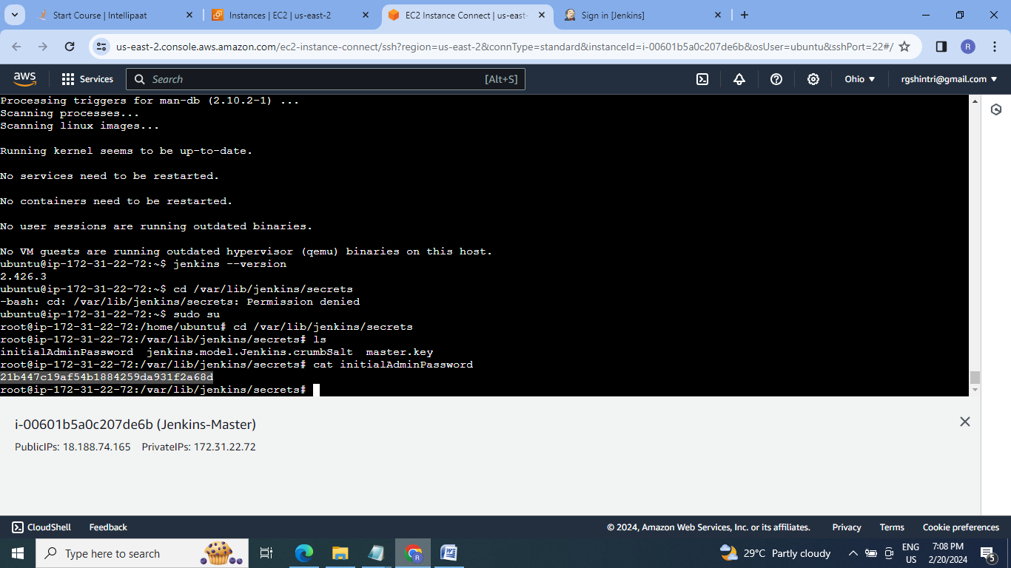

4.Install the plugins:

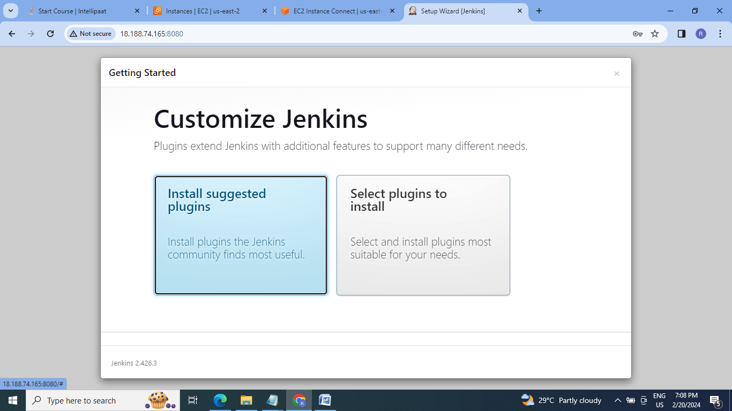

5.Create the User:

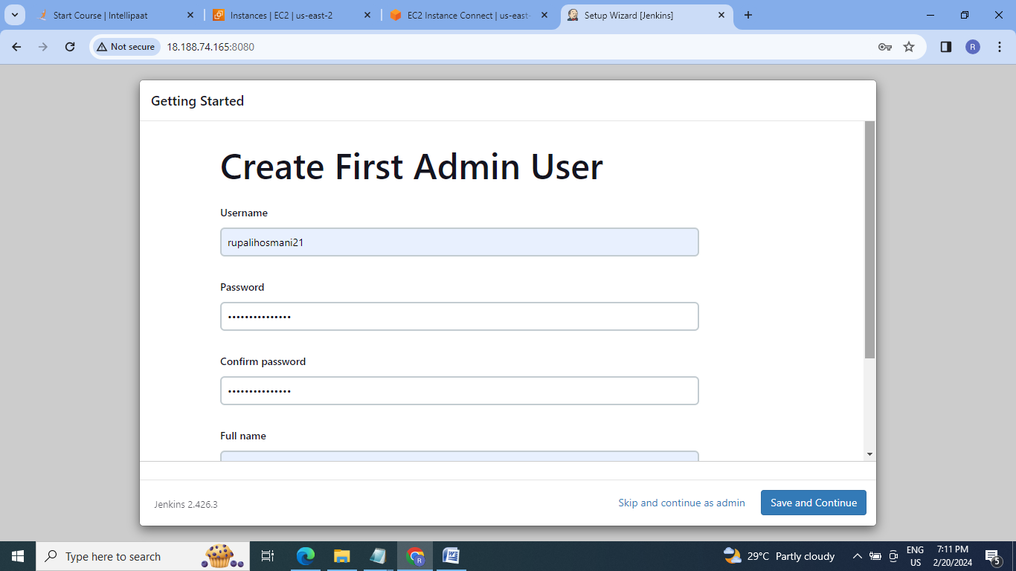

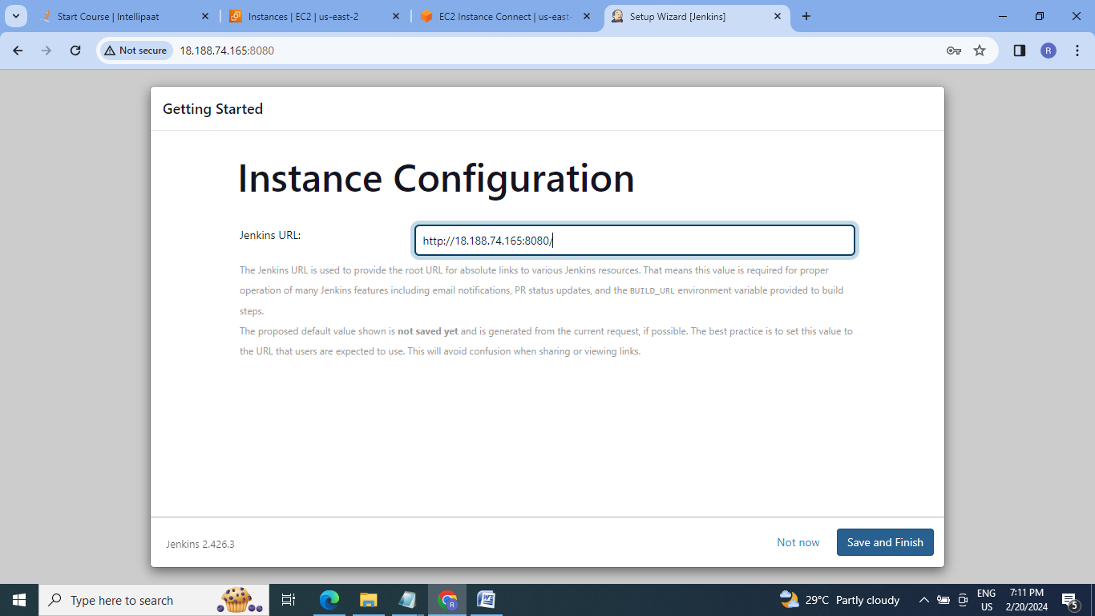

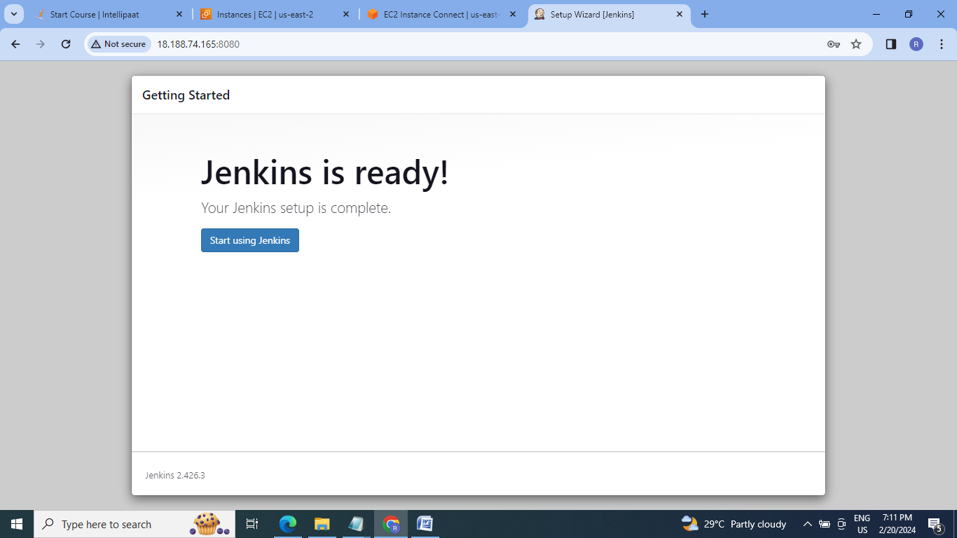

6.It will open the Jenkins Dashboard:

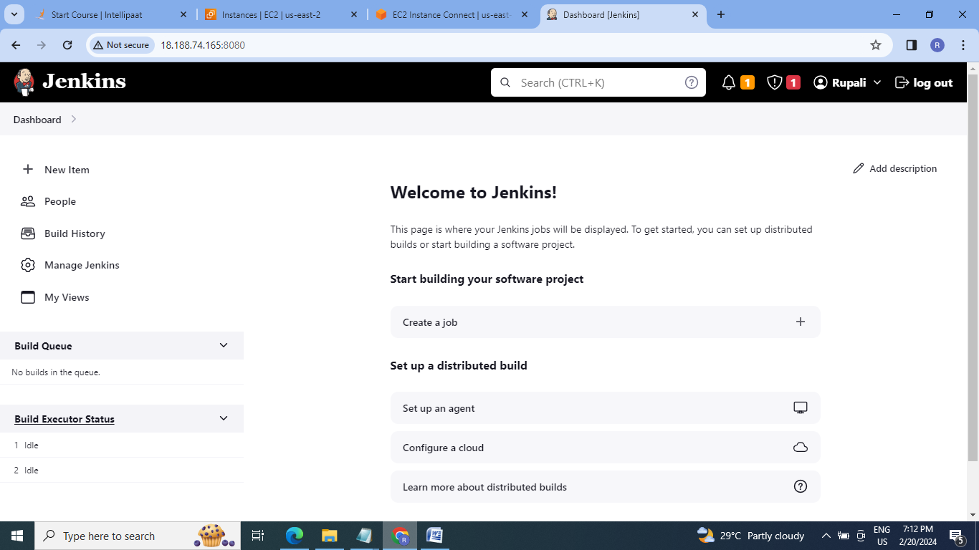

7.Cerate the job to Trigger a pipeline using Git when push on Develop branch:

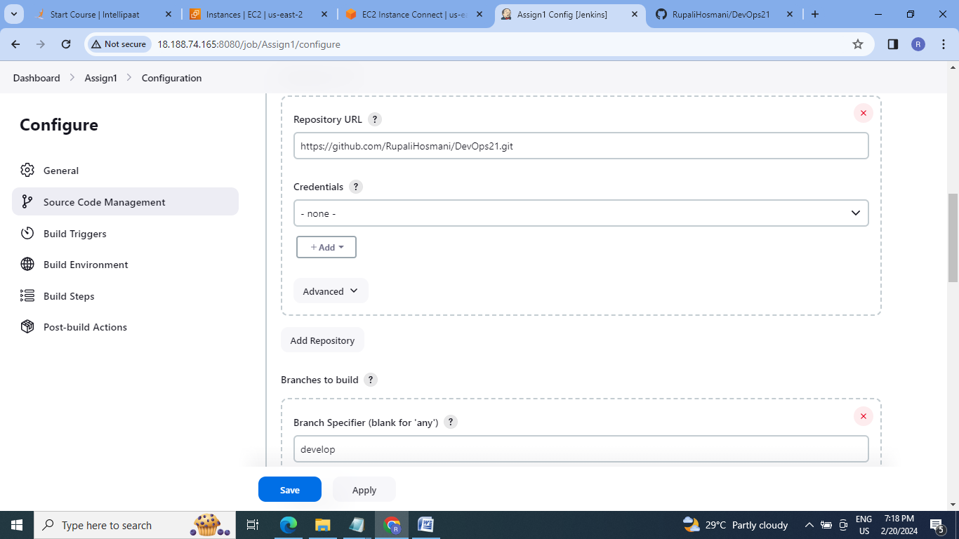

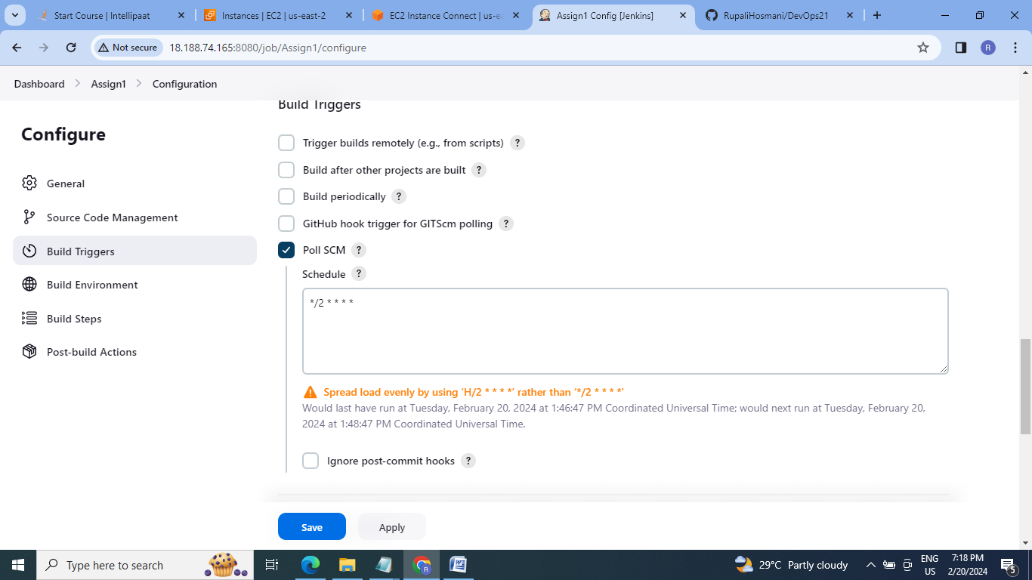

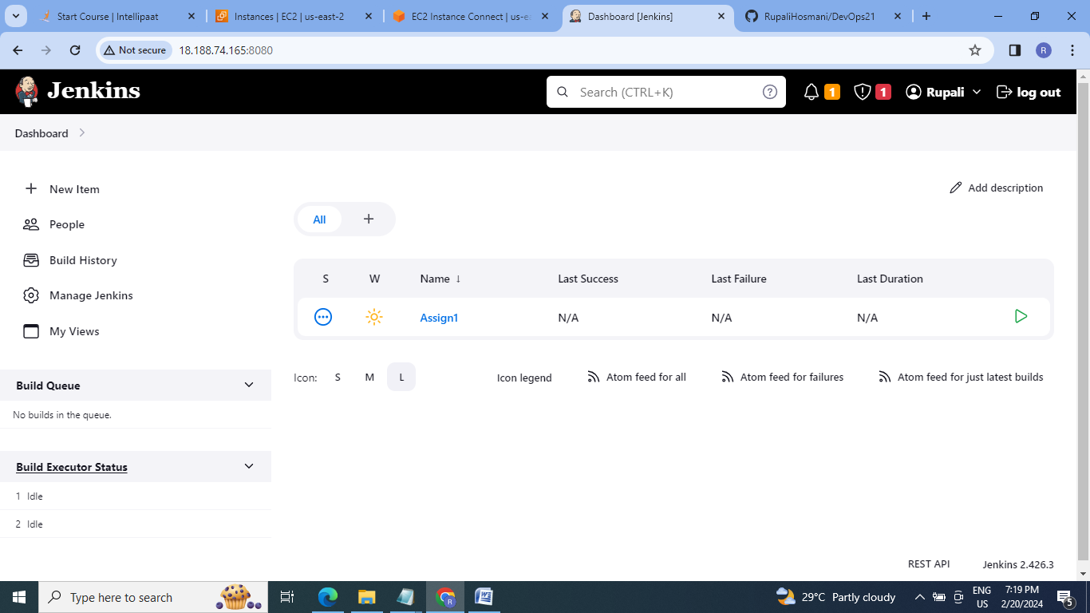

8.Now push some changes on develop branch & check :

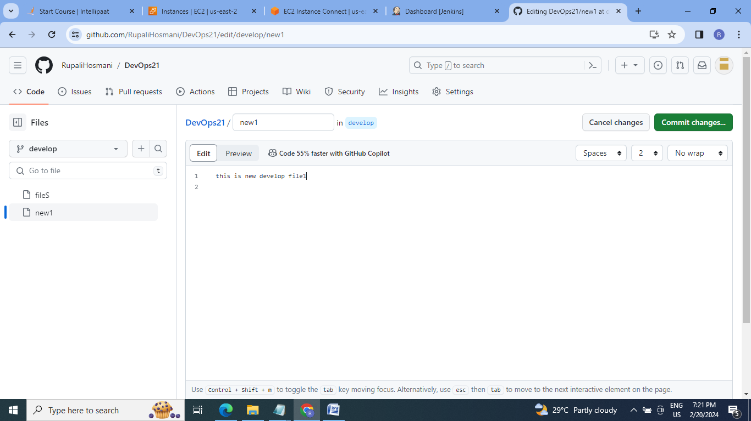

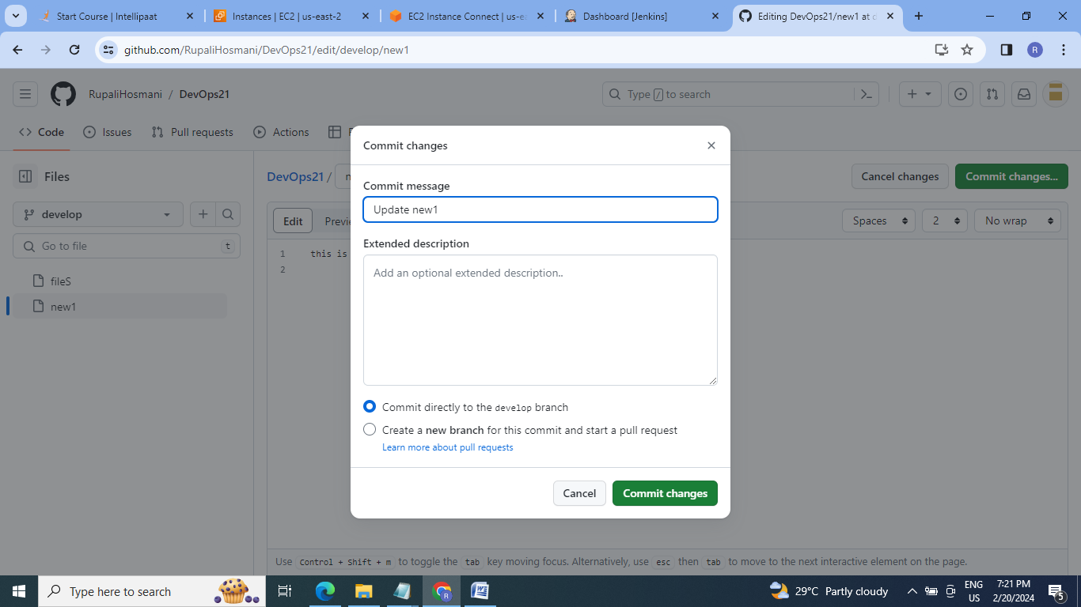

9.Job is triggered once change on develop branch is commited:

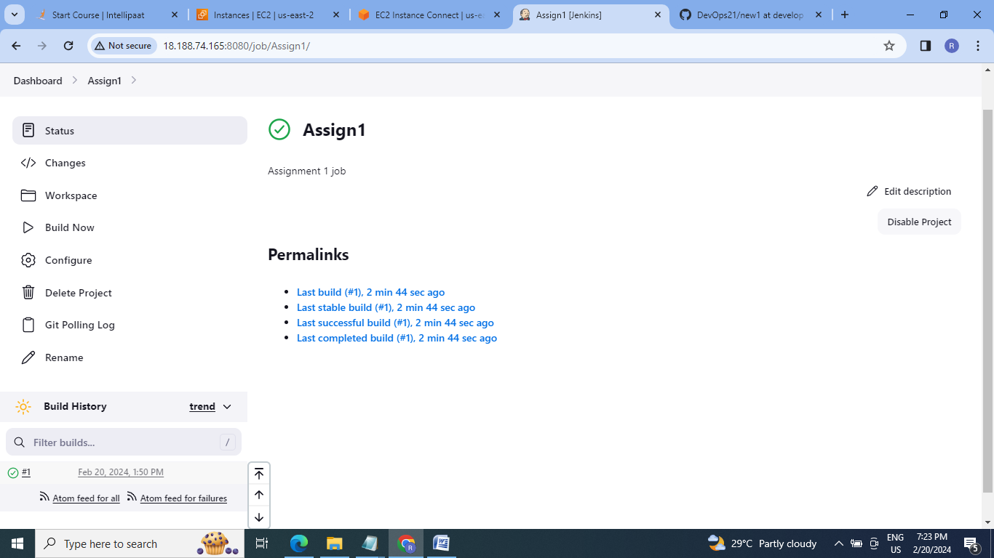

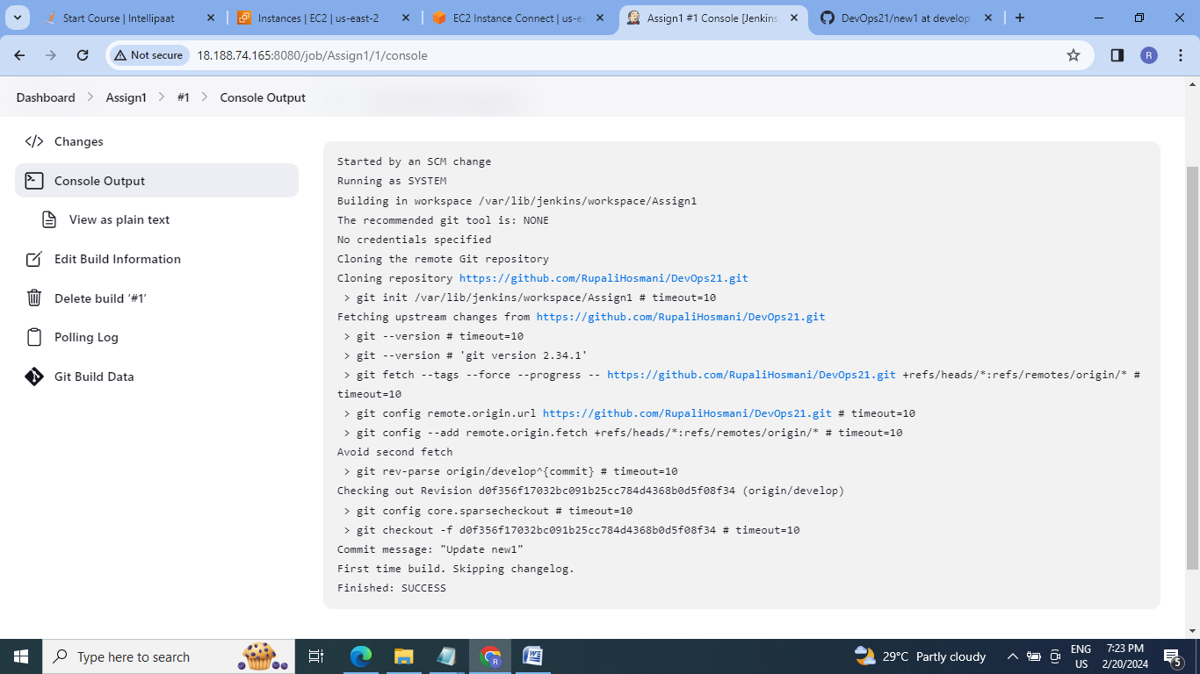

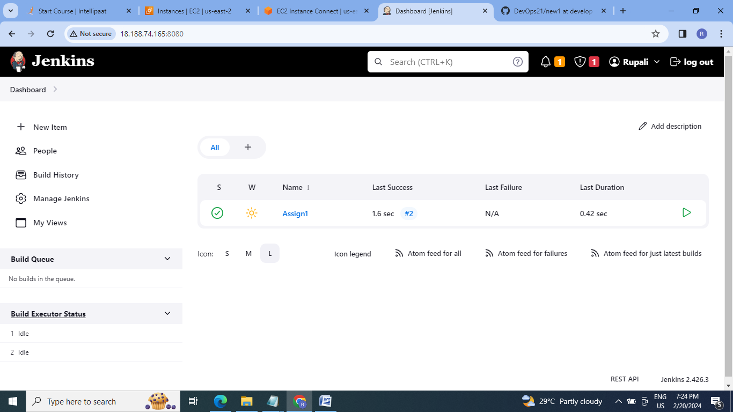

10. Check the Git contents at folder(Jenkins workspace):

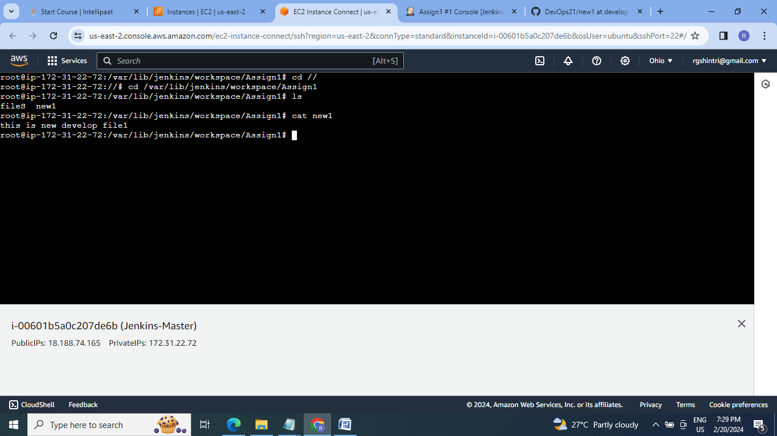

**B] Assignment 2:**

● Add 2 nodes to Jenkins master

● Create 2 jobs with the following jobs:

1. Push to test 2. Push to prod

● Once a push is made to test branch copy git files to test server

● Once a push is made to master branch copy git files to prod server

**Steps:**

1.Launch two new EC2 instances ,name them as Slave1 & Slave2, install java on both the slave.

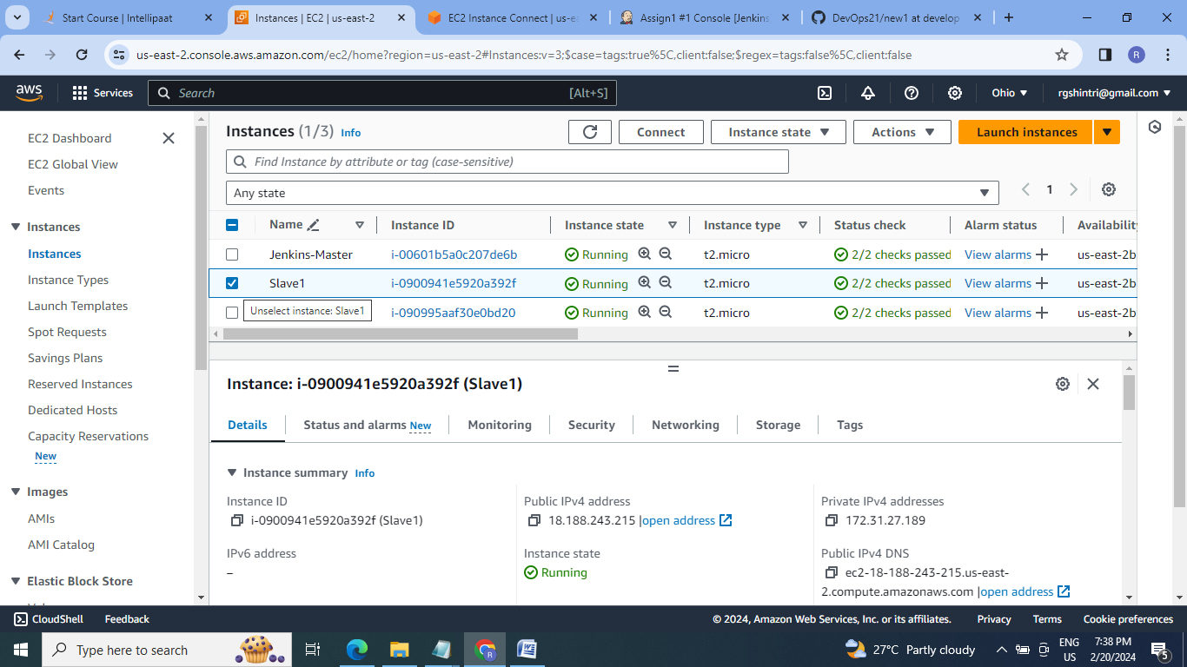

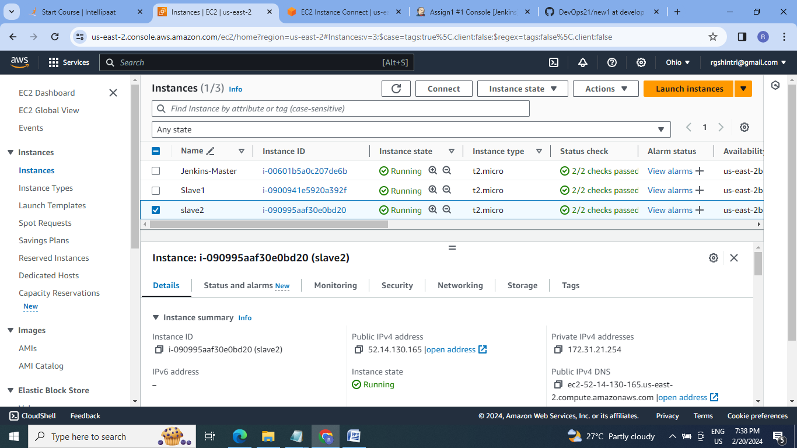

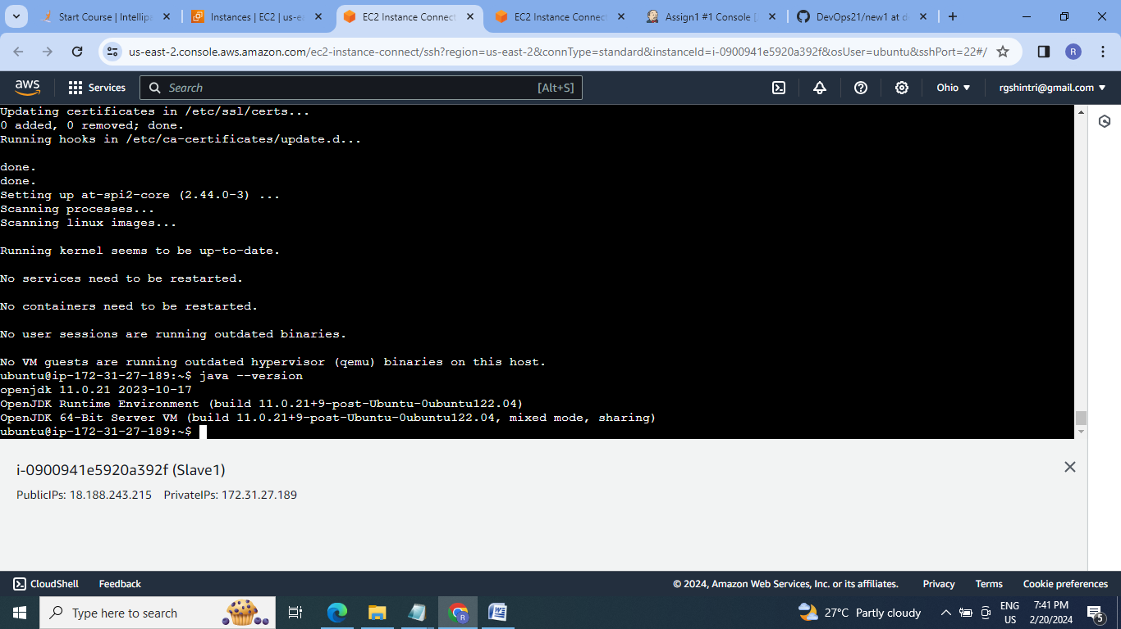

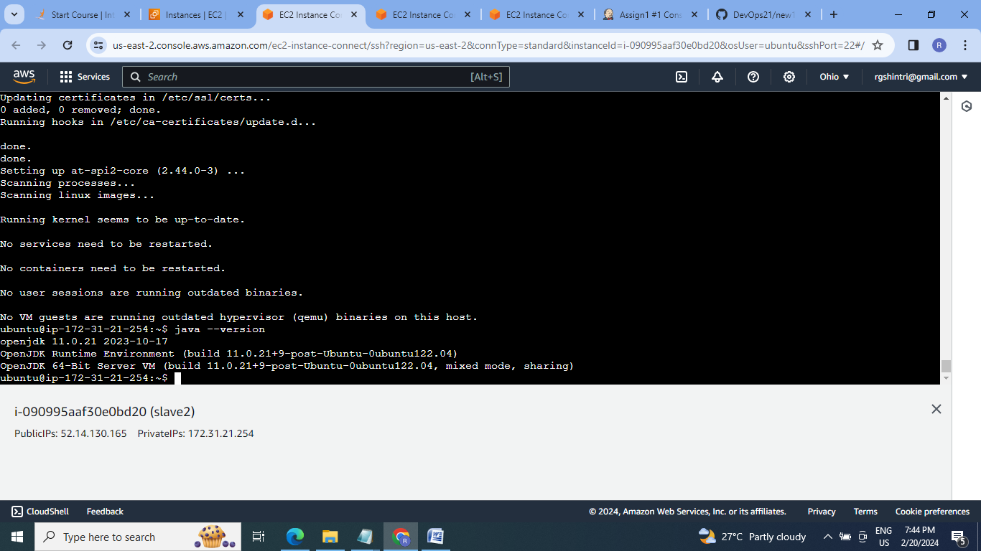

2.Connect both the slaves to Jenkins-Master by passwordless ssh method . 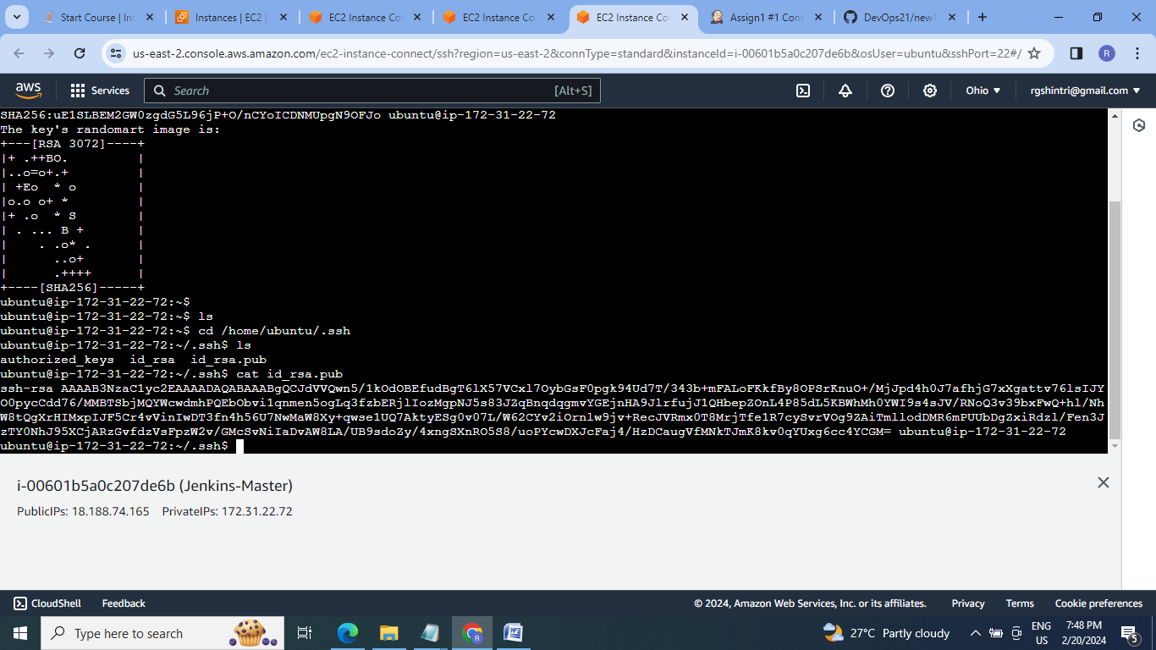

3. Copy the id_rsa public key to both slaves authorized key.

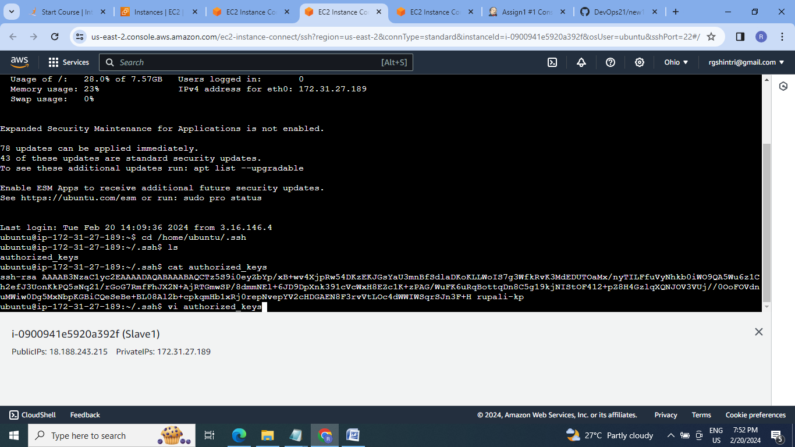

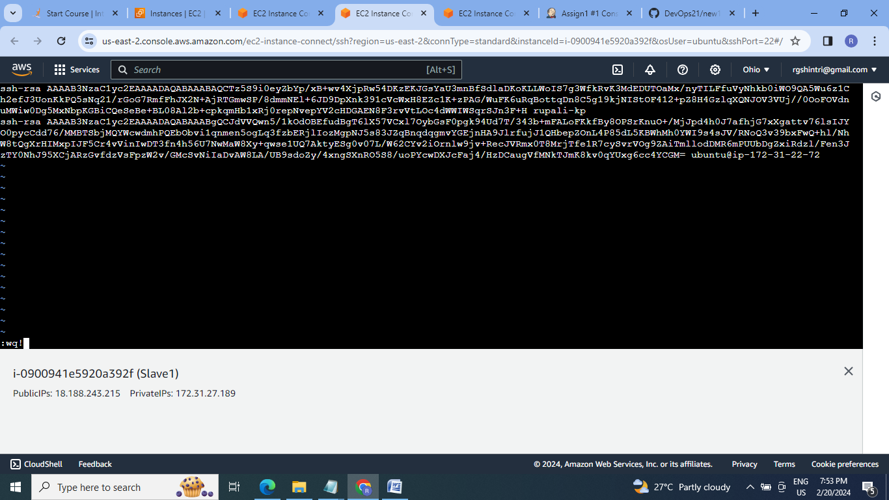

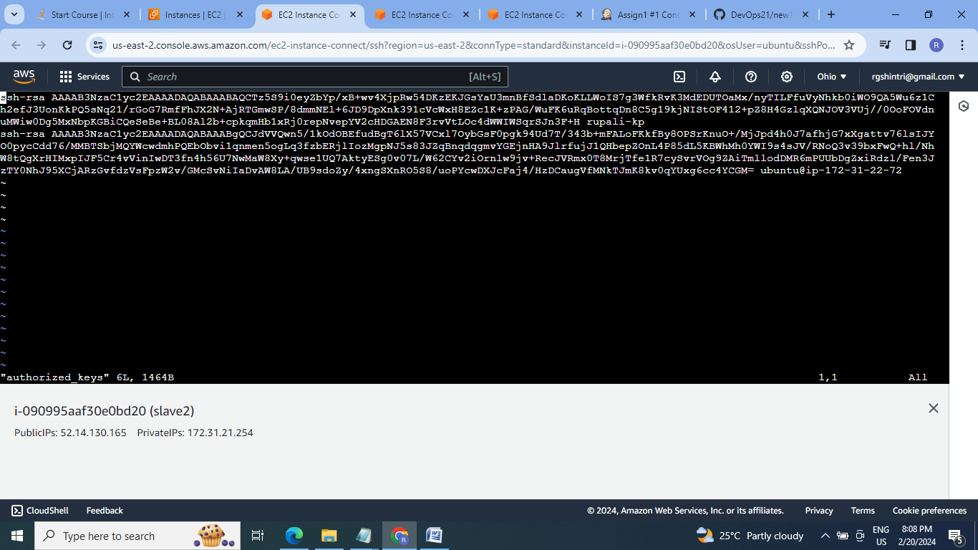

4. Go to Jenkins-master & connect the slave1 & slave2

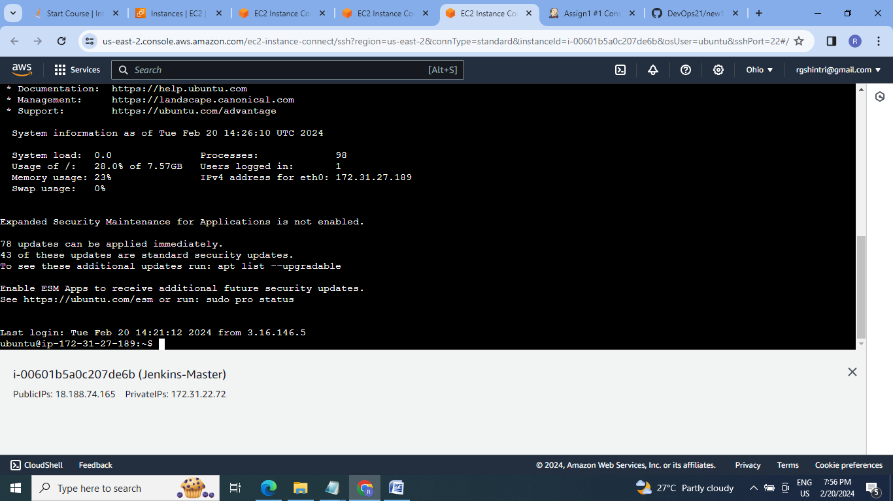

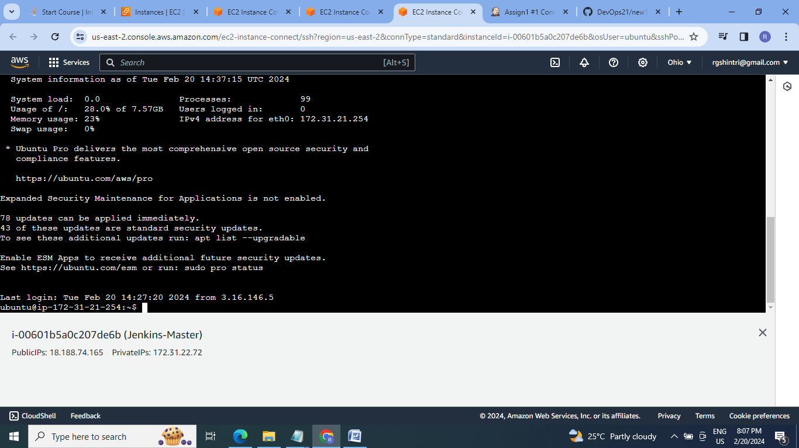

5. Configure both the slaves as nodes in Jenkins GUI:

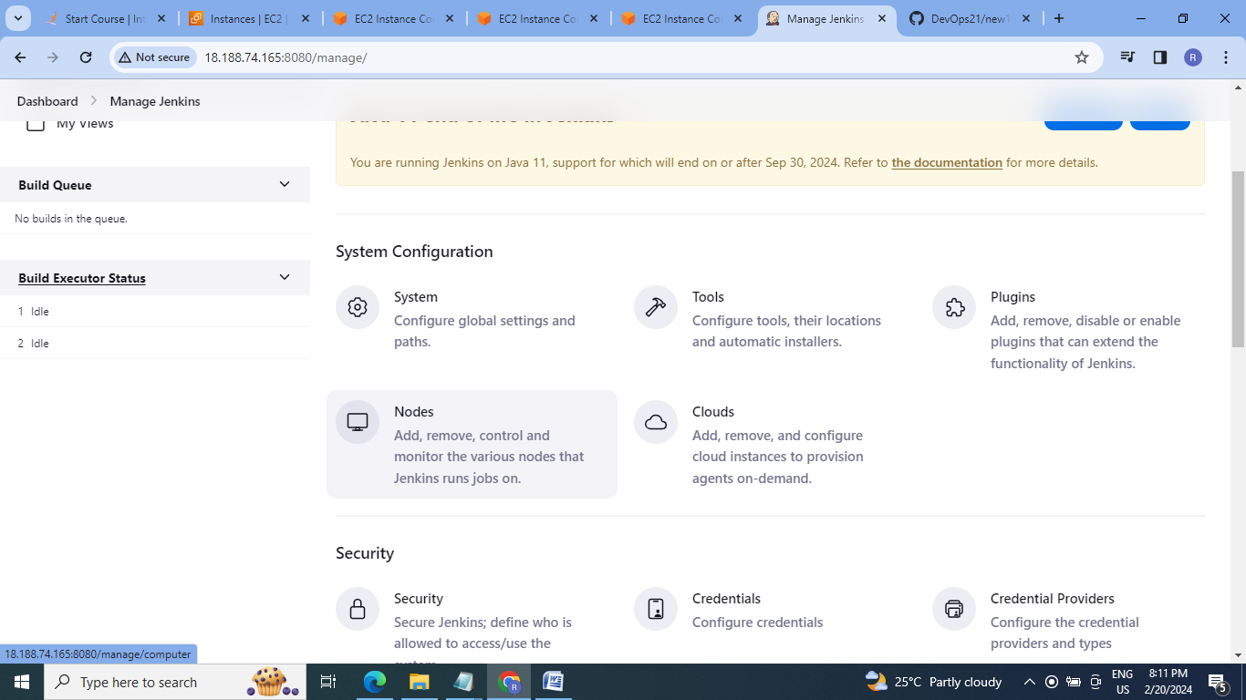

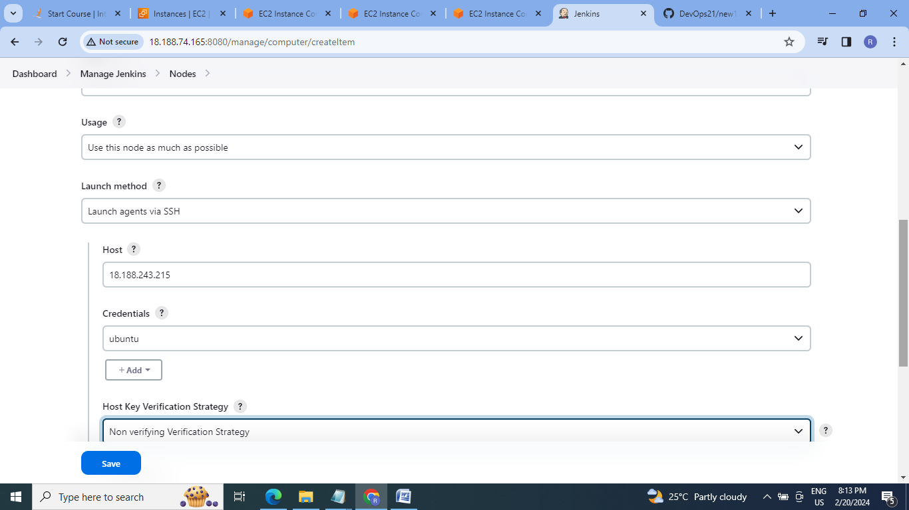

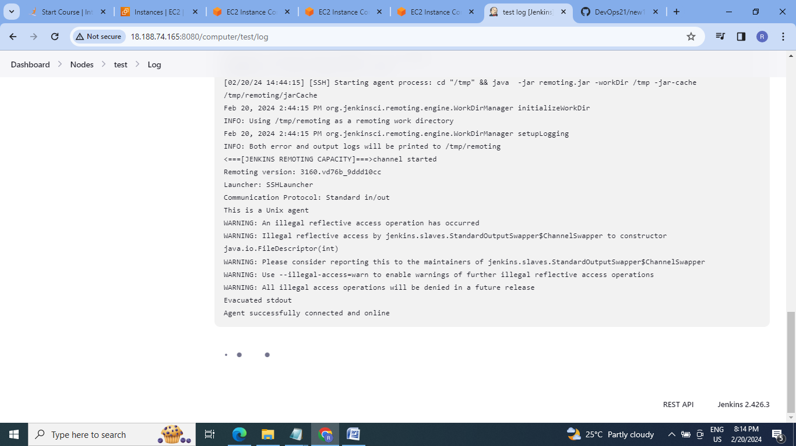

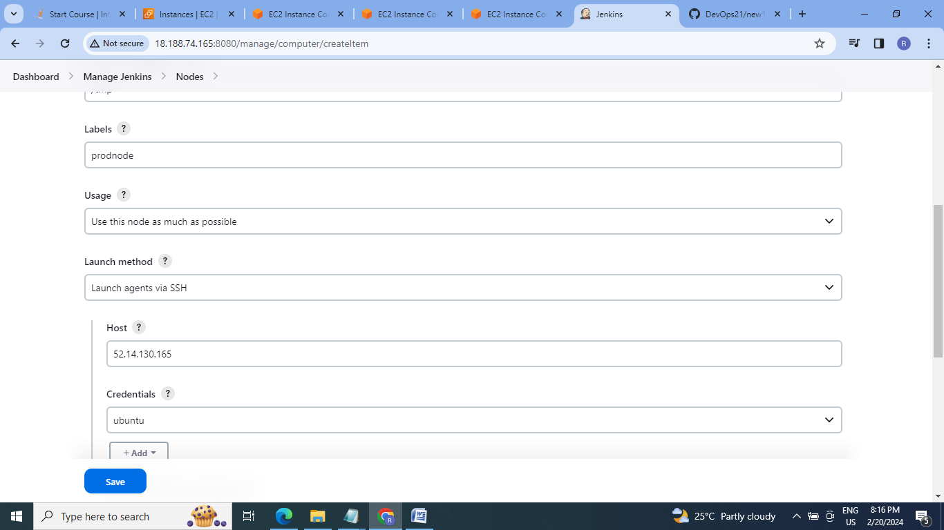

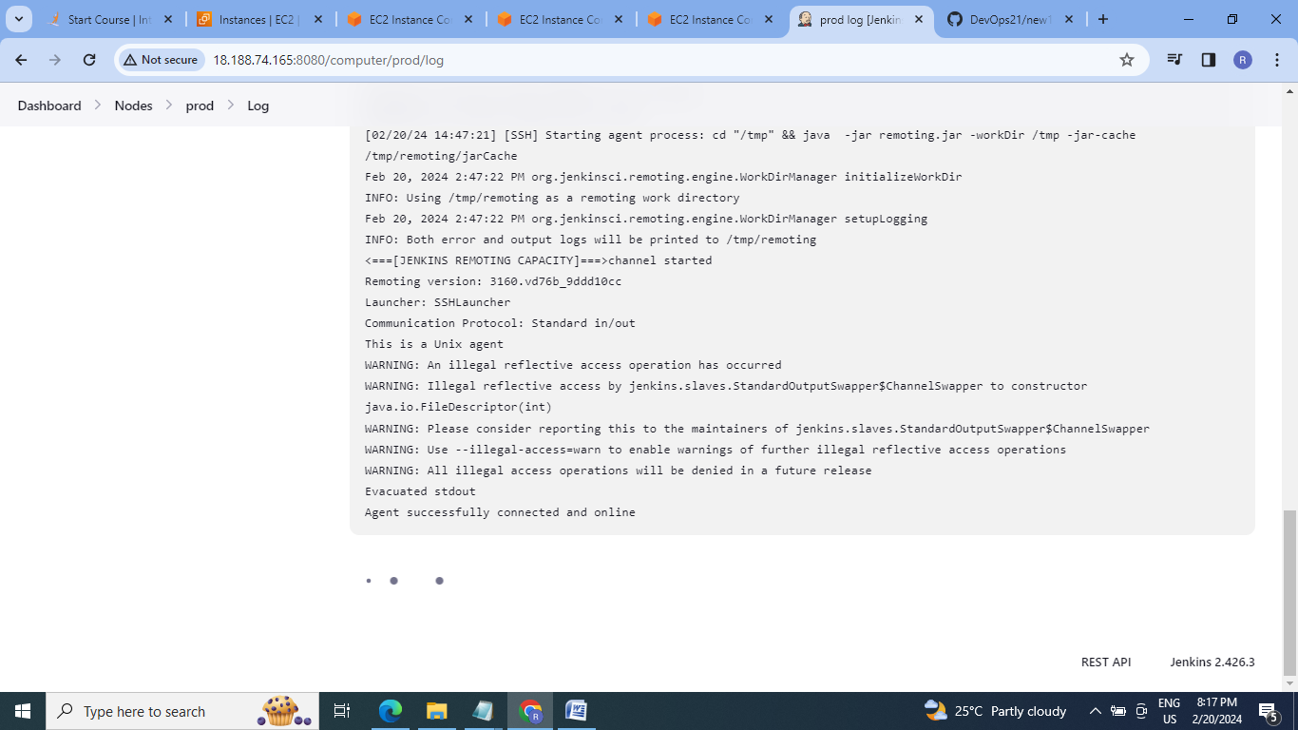

6. Test & Prod nodes created:

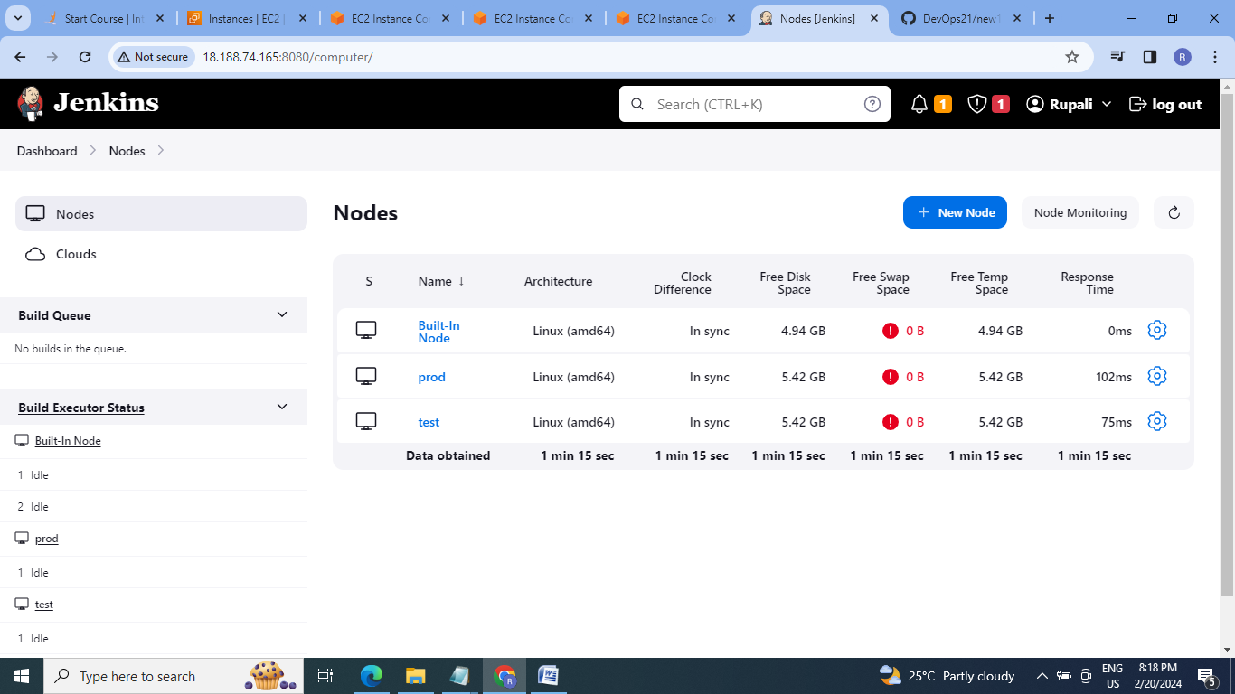

7. Create job1 should run when push is made to test branch copy git files to test server:

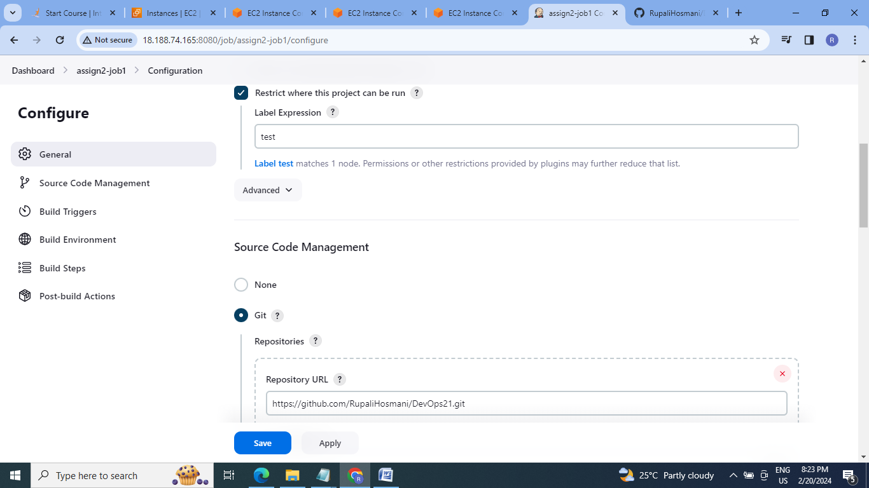

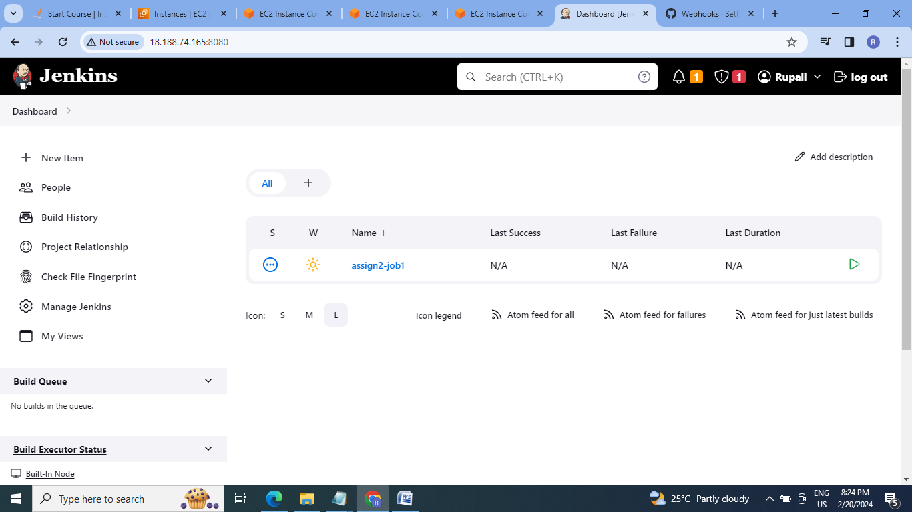

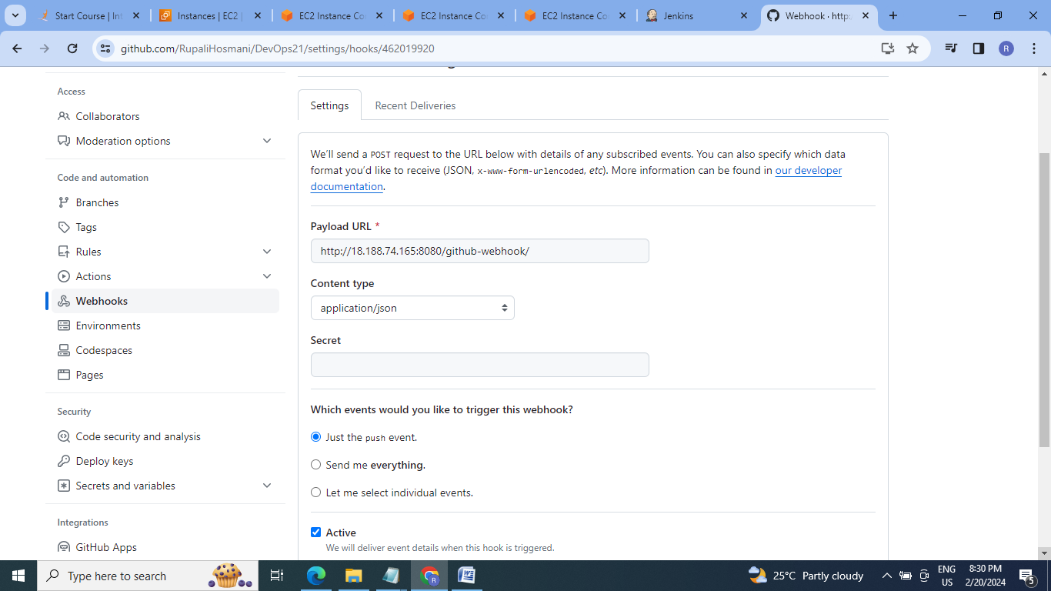

8. Push the changes made in test branch of github repo.

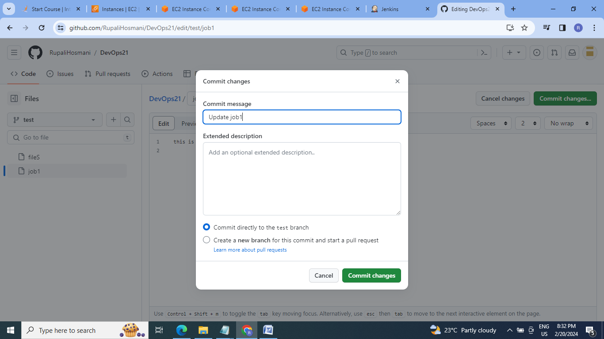

9. Check for build run of job1:

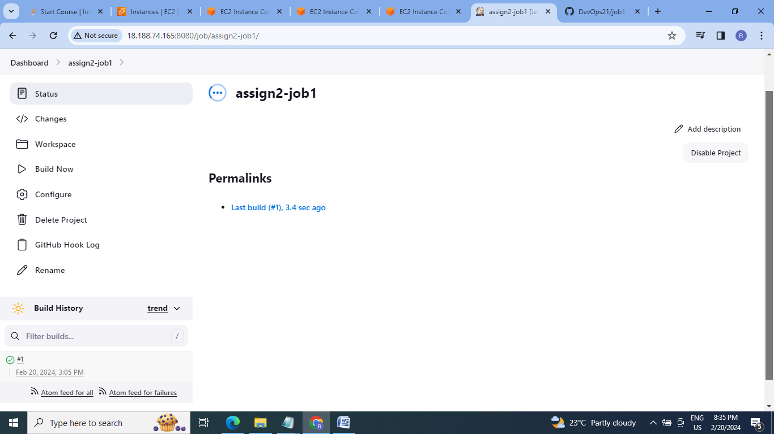

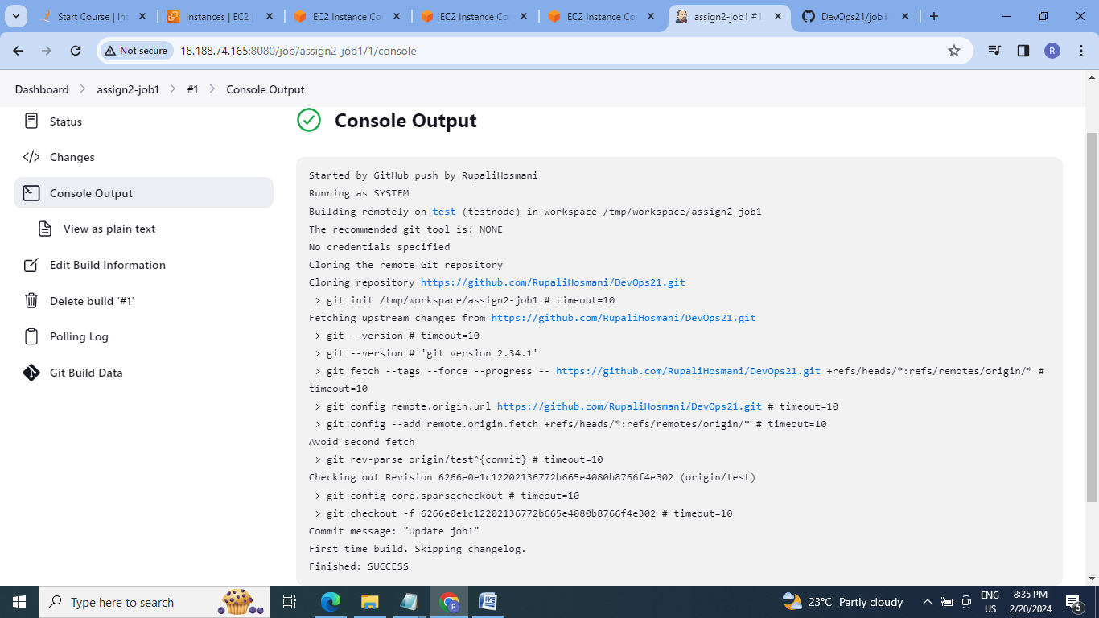

10.Check for the git file at test server(slave1):

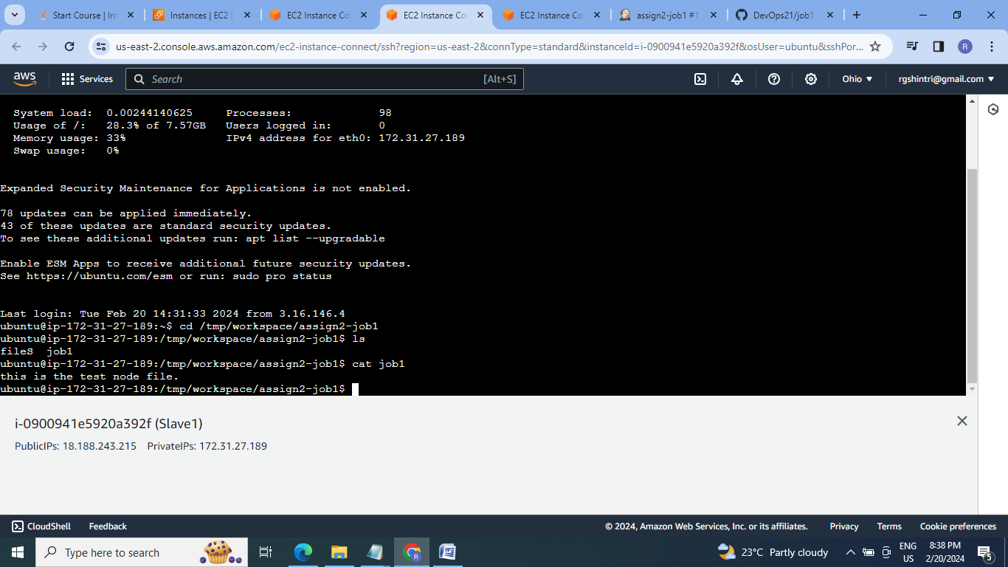

11. Create job2 that should run when push is made to master branch copy git files to prod server(slave2):

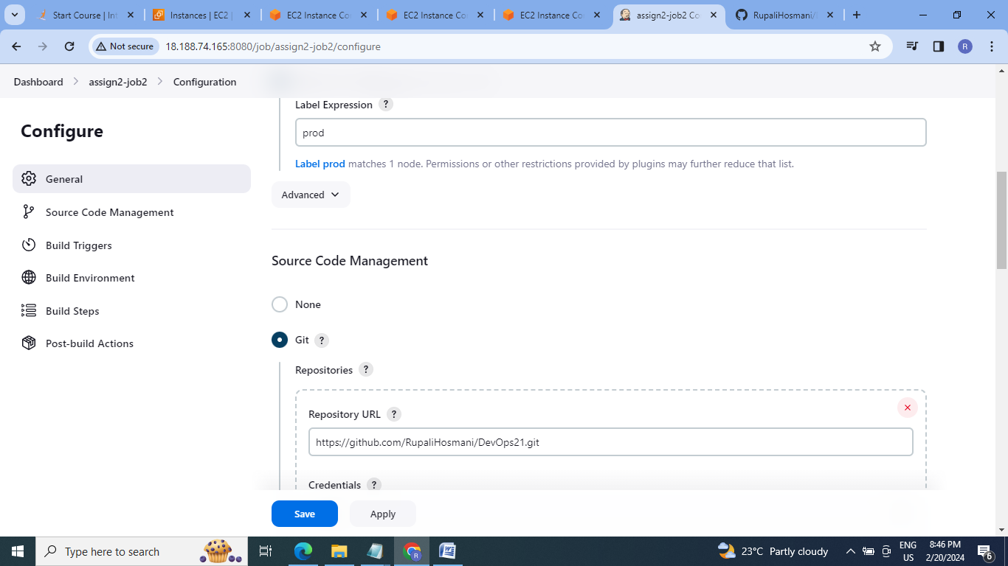

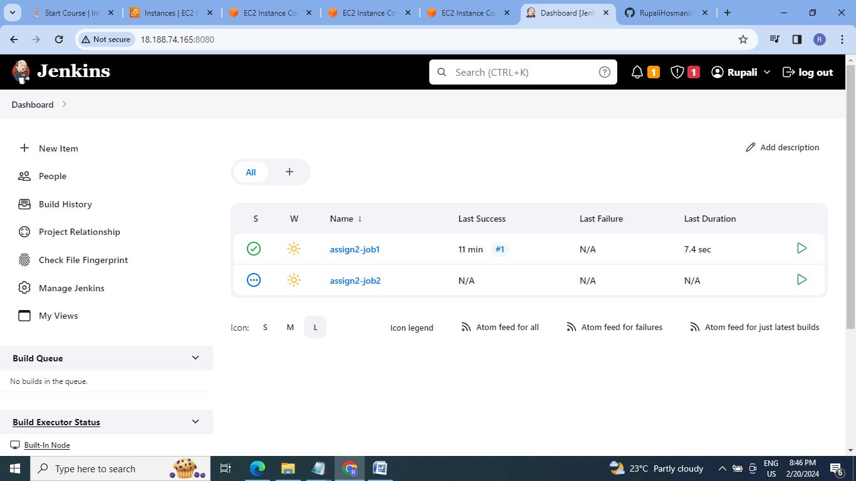

12.Go to Github repo master branch & commit some changes:

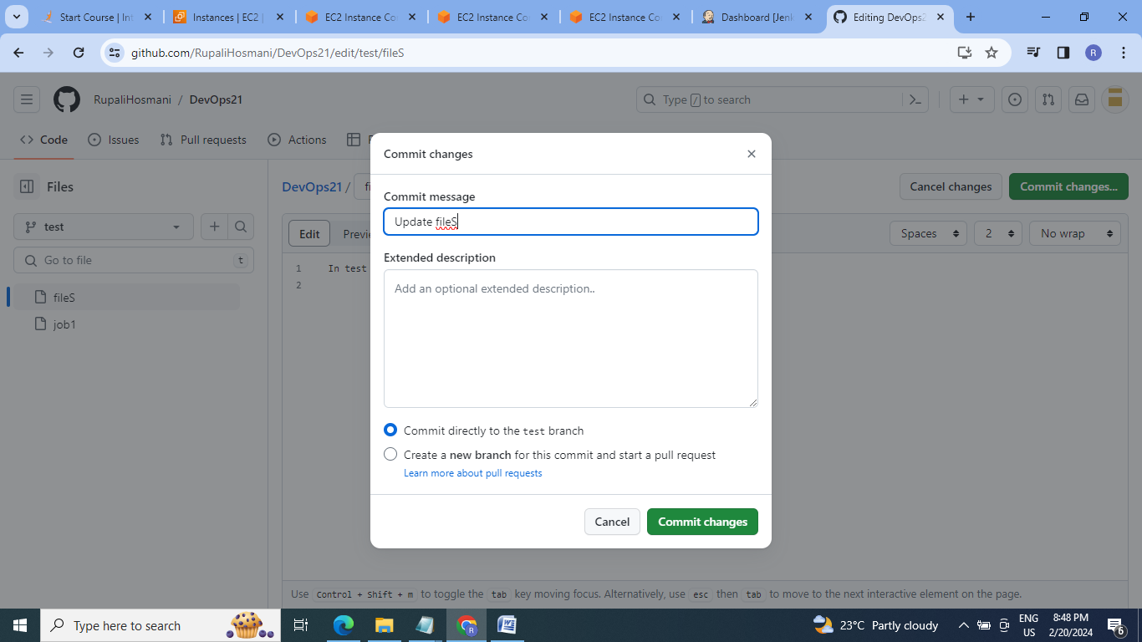

13.Check for job2 build run

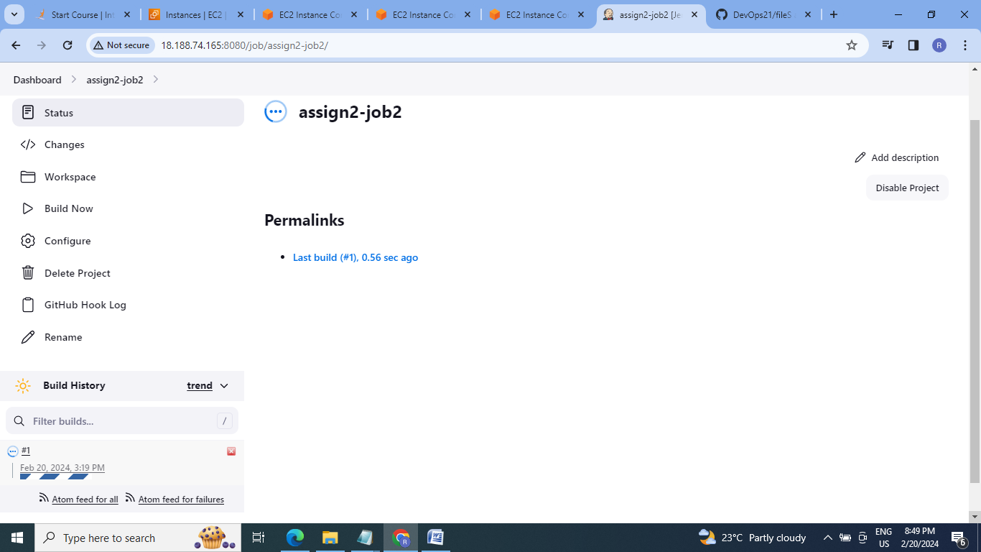

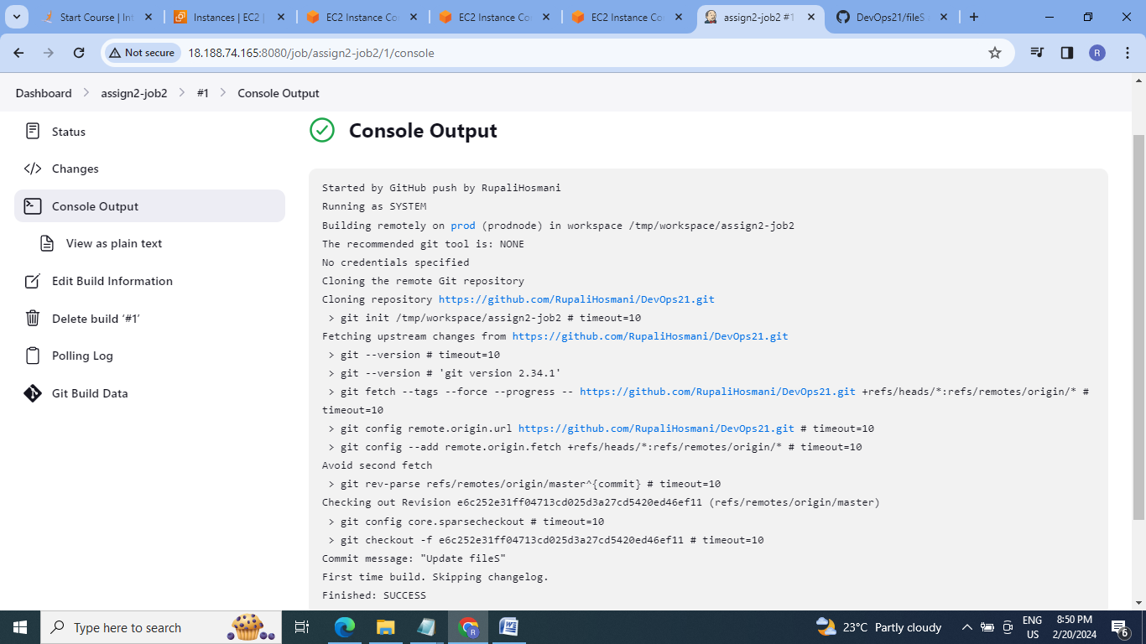

14. Check for git master branch file on prod server (slave2):

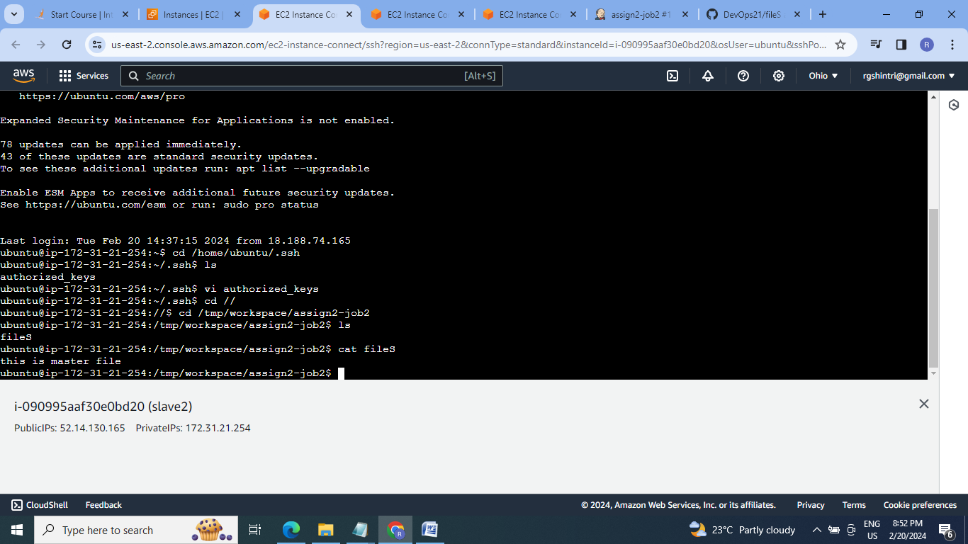

**C]Assignment 3:**

● Create a pipeline in jenkins

● Once push is made to “develop” branch in git, trigger job “test”. This will copy git files to test node

● If test job is successful, then prod job should be triggered

● Prod jobs should copy files to prod node

**Steps:**

1.Configure the Assign2 –job1 & Assign 2-job2 for getting Assign2-job2 triggered by assign2- job1 once the changes are committed at develop branch of github repo.

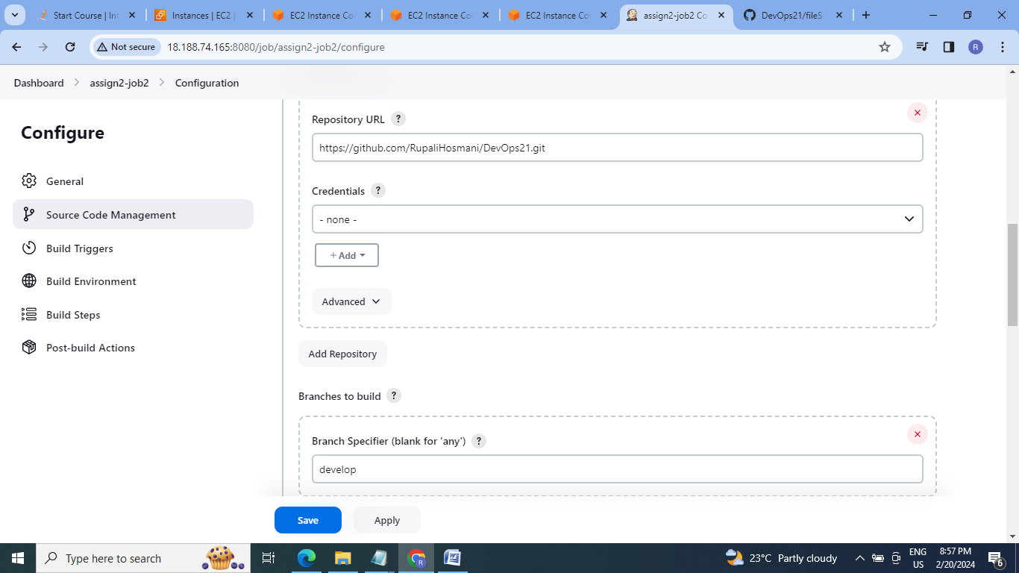

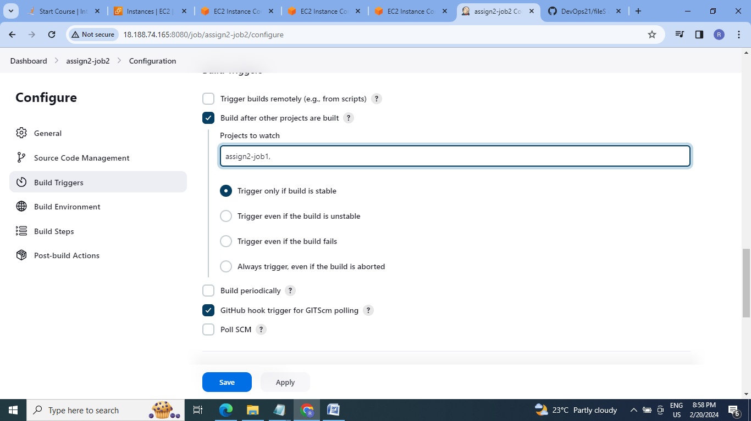

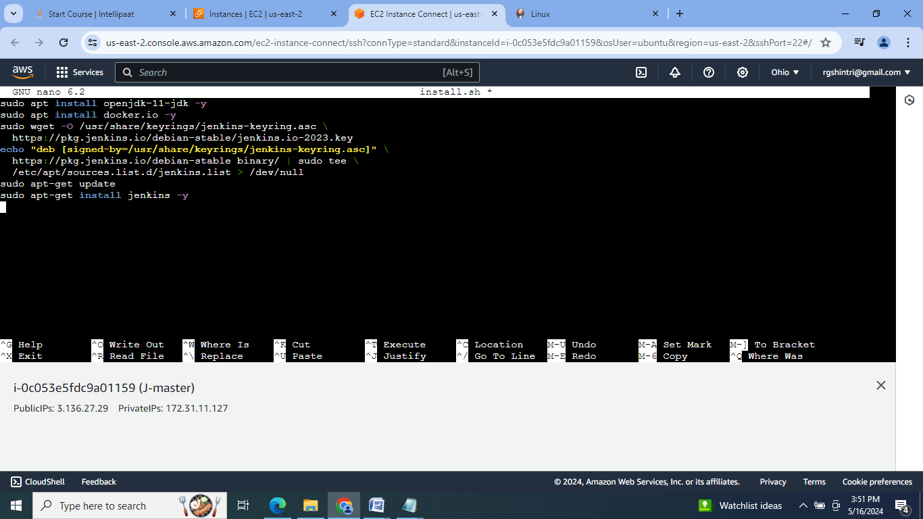

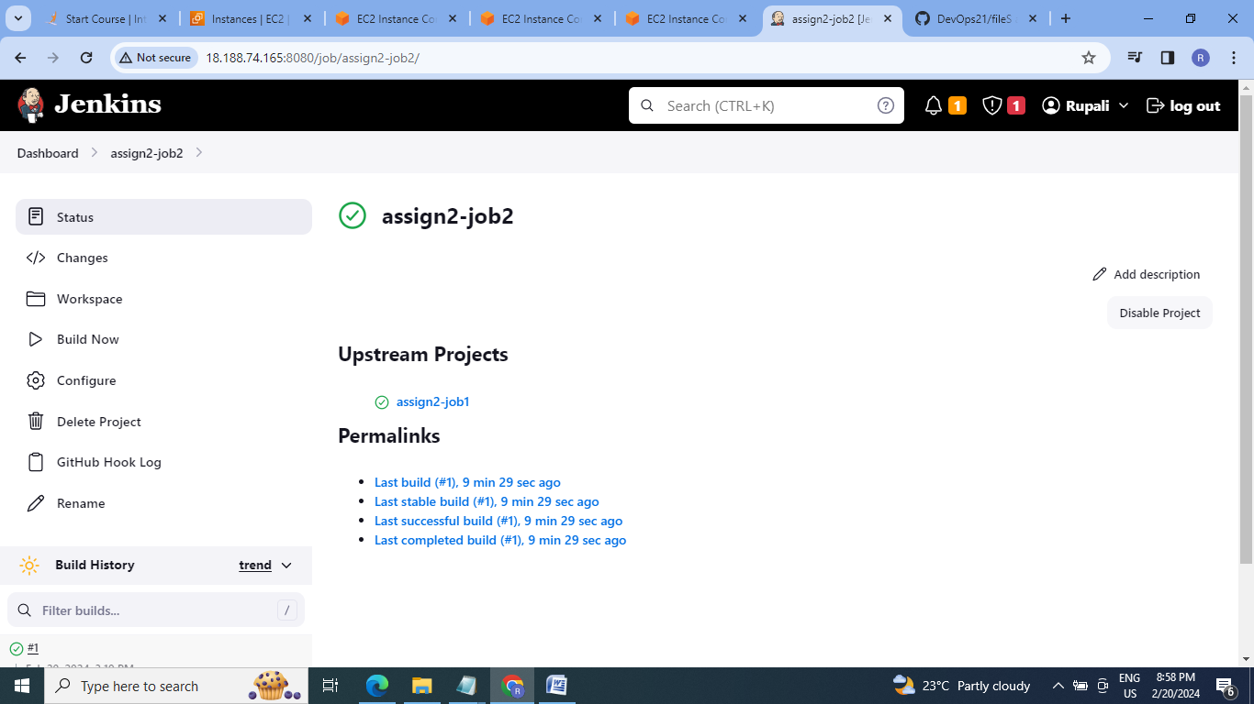

2.Go to github repo develop branch & commit changes& chech for build run:

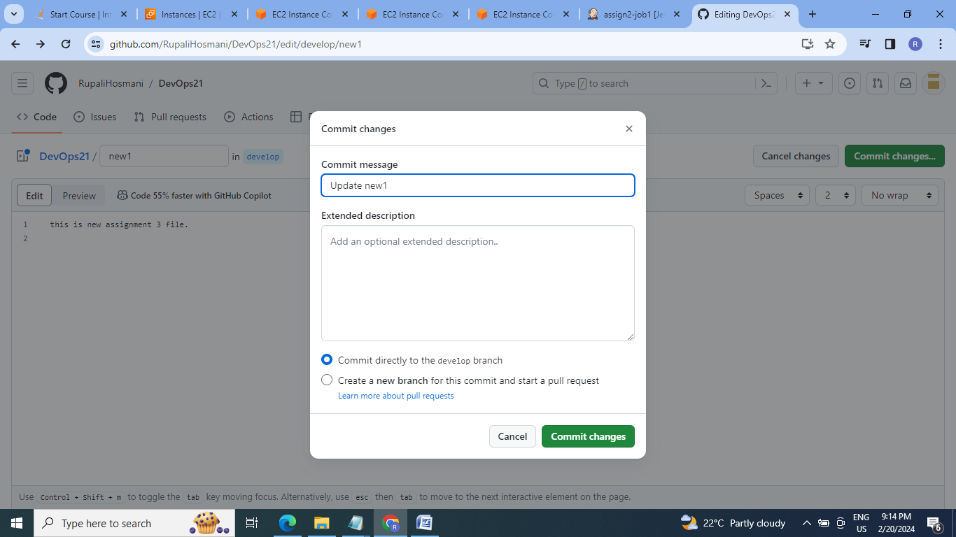

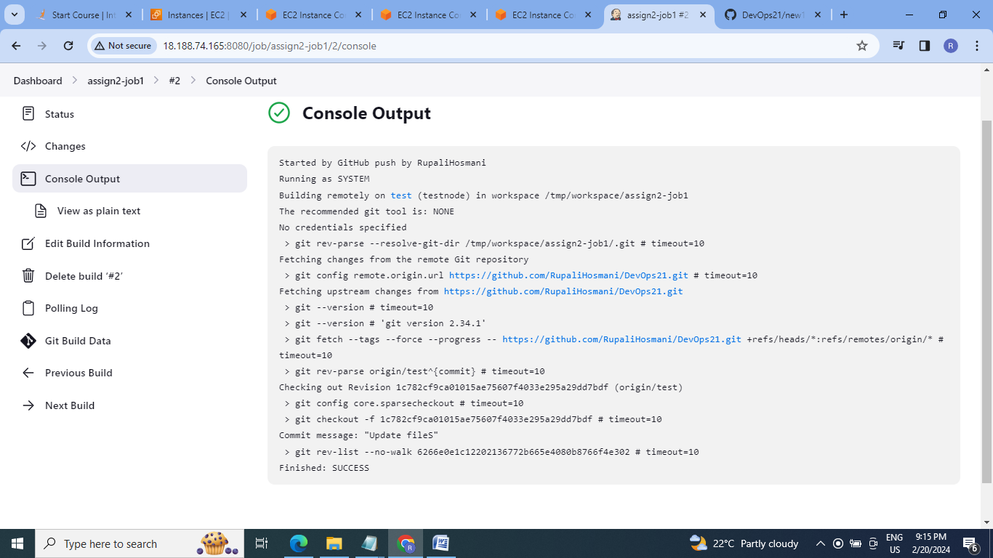

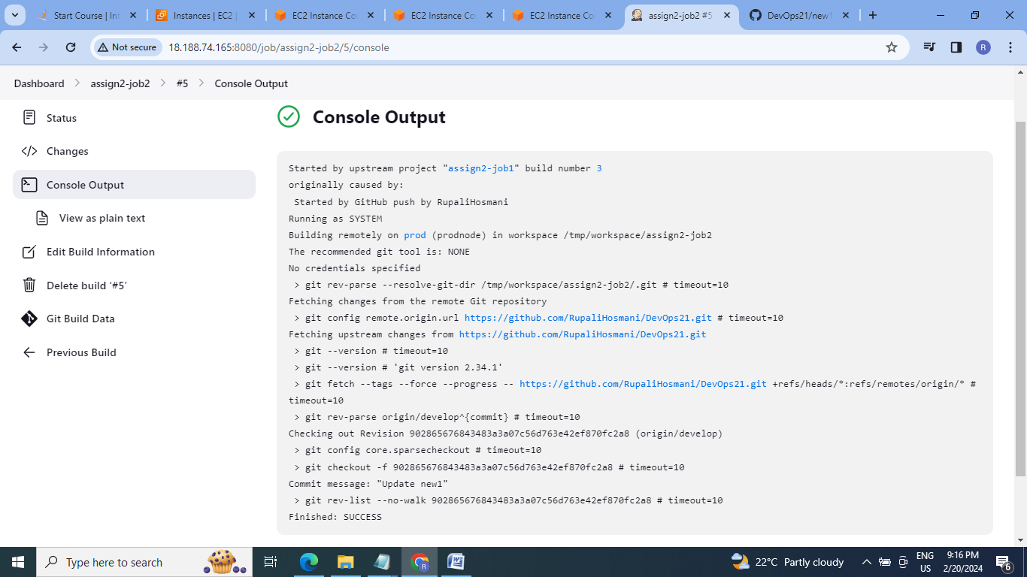

3. Go to test server(slave1) & prod server (slave2) check for git files:

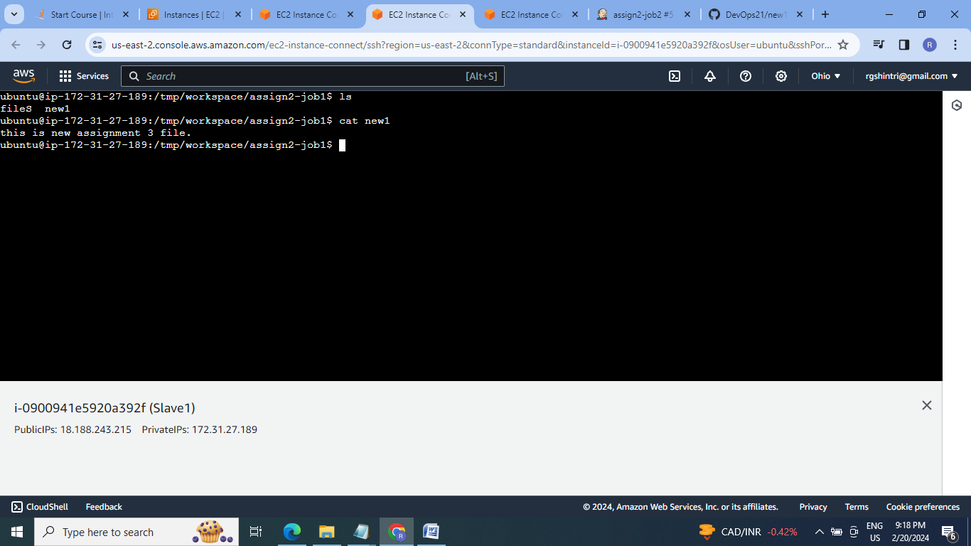

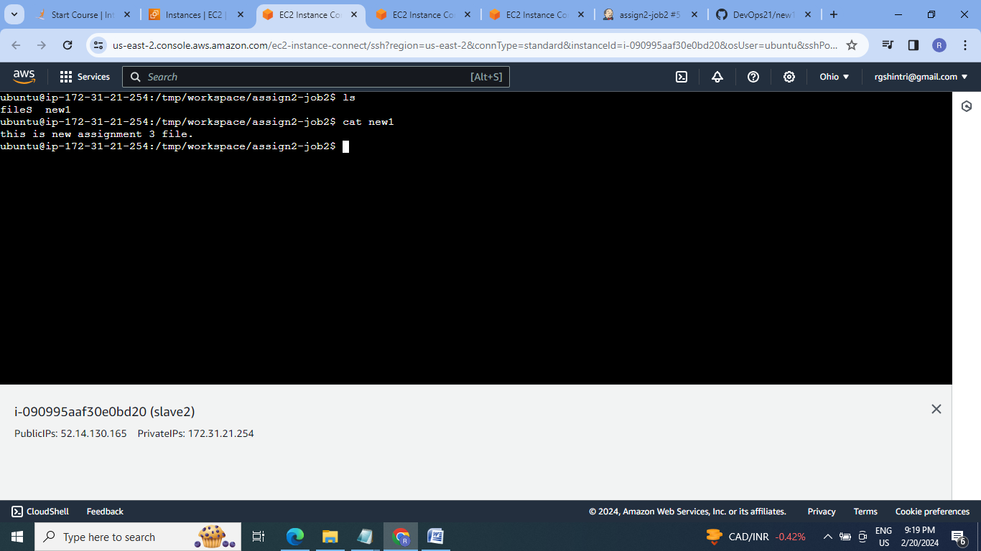

**Conclusion:** Jenkins is an open source automation tool which helps to automate software development process by doing the continuous integration & providing the base for continuous delivery.

